Implement Snowflake Streams for Sales Data Processing

A retail company receives sales data in a staging table. The company wants to load this data into a final reporting table. After the initial load, only newly inserted or updated records should be processed using Snowflake Streams.
You need to create the database, tables, stream object, insert records, consume stream data, and update the final table using stream changes.

Task 1: Create Database
Create a transient database named:
Query:
CREATE OR REPLACE DATABASE STREAMS_DB;
Output:
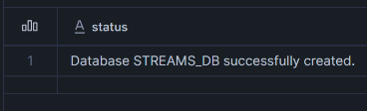

Task 2: Create Raw Sales Staging Table
Create a table named:
SALES_RAW_STAGING
The table should contain the following columns:
- id
- product
- price
- amount
- store_id
Use suitable data types.
Query:
USE DATABASE STREAMS_DB;
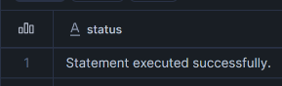
USE SCHEMA PUBLIC;

CREATE OR REPLACE TABLE STREAMS_DB.PUBLIC.SALES_RAW_STAGING(
id INT,
product STRING,
price DECIMAL(10,2),
amount INT,
store_id INT
);
Output:
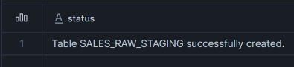

Task 3: Insert Initial Sales Data
Insert the following five records into SALES_RAW_STAGING:
id product price amount store_id
1 Banana 1.99 1 1
2 Lemon 0.99 1 1
3 Apple 1.79 1 2
4 Orange Juice 1.89 1
5 Cereals 5.98 2 1
Query:
INSERT INTO SALES_RAW_STAGING VALUES
(1,'Banana',1.99,1,1),
(2,'Lemon',0.99,1,1),
(3,'Apple',1.79,1,2),
(4,'Orange Juice',1.89,1,NULL),
(5,'Cereals',5.98,2,1);
Output:

Task 4: Create Store Table
Create a table named:
STORE_TABLE
The table should contain:
store_id
location
employees
Query:
CREATE OR REPLACE TABLE STREAMS_DB.PUBLIC.STORE_TABLE(
store_id INT,
location STRING,
employees INT
);
Output:
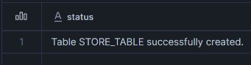

Task 5: Insert Store Data
Insert the following records into STORE_TABLE:
store_id location employees
1 Chicago 33
2 London 12
Query:
INSERT INTO STORE_TABLE VALUES
(1,'Chicago',33),
(2,'London',12);
Output:

Task 6: Create Final Sales Table
Create a table named:
SALES_FINAL_TABLE
The table should contain:
id
product
price
amount
store_id
location
employees
This table will store sales data along with store location and employee details.
Query:
CREATE OR REPLACE TABLE STREAMS_DB.PUBLIC.SALES_FINAL_TABLE(
id INT,
product STRING,
price DECIMAL(10,2),
amount INT,
store_id INT,
location STRING,
employees INT
);

Output:
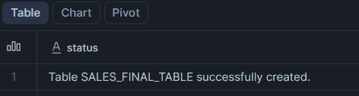

Task 7: Perform Initial Full Load
Load data from SALES_RAW_STAGING into SALES_FINAL_TABLE.
While loading, join:
SALES_RAW_STAGING
with:
STORE_TABLE
using STORE_ID.
Query:
INSERT INTO SALES_FINAL_TABLE
SELECT
S.ID,
S.PRODUCT,
S.PRICE,
S.AMOUNT,
S.STORE_ID,
ST.LOCATION,
ST.EMPLOYEES
FROM SALES_RAW_STAGING S
LEFT JOIN STORE_TABLE ST
ON S.STORE_ID = ST.STORE_ID;
Output:

Task 8: Verify Initial Load
Display data from:
SALES_RAW_STAGING;
STORE_TABLE;
SALES_FINAL_TABLE;
Confirm that SALES_FINAL_TABLE contains 5 records.
Query:
SELECT * FROM SALES_RAW_STAGING;
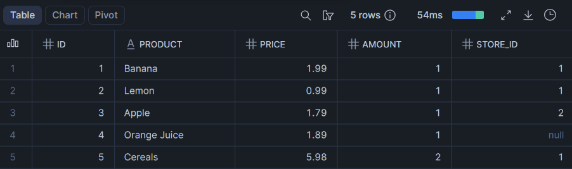
SELECT * FROM STORE_TABLE;
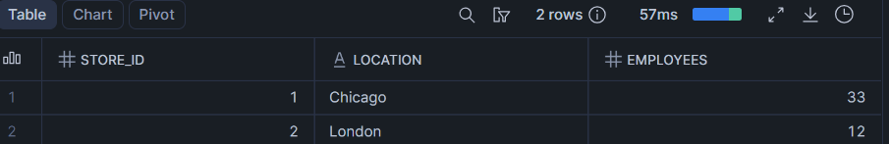
SELECT * FROM SALES_FINAL_TABLE;
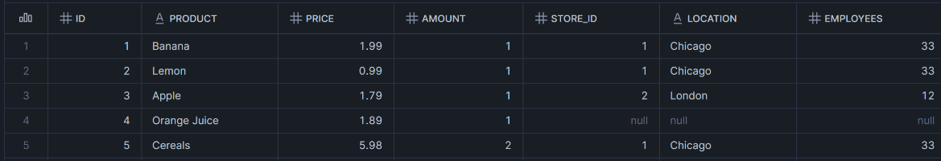
Stream Implementation

Task 9: Create Stream Object
Create a stream named:
SALES_STREAM
on top of:
SALES_RAW_STAGING
Query:
CREATE OR REPLACE STREAM SALES_STREAM ON TABLE SALES_RAW_STAGING;
Output:
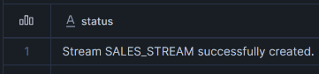

Task 10: View Stream Information
Execute commands to:
Show all streams.
Describe the SALES_STREAM.
Select data from SALES_STREAM.
Query:
SHOW STREAMS;
DESC STREAM SALES_STREAM;
SELECT * FROM SALES_STREAM;
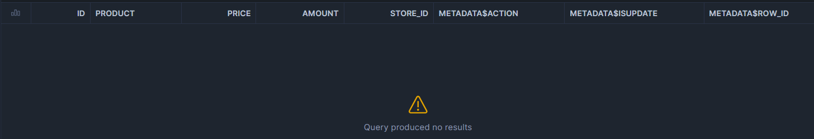
Answer this question:
Why is SALES_STREAM empty immediately after creation?
Ans:
Because, Streams only capture insert,delete and update operations that happens after the stream creation. So, as there are no data changes occurred after SALES_STREAM creation it is empty.
Insert Change Capture

Task 11: Insert New Sales Records
Insert the following two records into SALES_RAW_STAGING:
id product price amount store_id
6 Mango 1.99 1 2
7 Garlic 0.99 1 1
Query:
INSERT INTO SALES_RAW_STAGING VALUES
(6,'Mango',1.99,1,2),
(7,'Garlic',0.99,1,1);
Output:

Task 12: Check Stream Data
Query SALES_STREAM.
Observe the new records and metadata columns:
METADATA$ACTION
METADATA$ISUPDATE
METADATA$ROW_ID
Query:
SELECT * FROM SALES_STREAM;
Output:
Answer this question:
What value do you see in METADATA$ACTION for newly inserted records?
Ans:
Under the METADATA$ACTION column, the value is ‘INSERT’ because we used the insert operations.

Task 13: Verify Source and Target Tables
Check data in:
SALES_RAW_STAGING;
SALES_FINAL_TABLE;
Query:
SELECT * FROM SALES_RAW_STAGING;
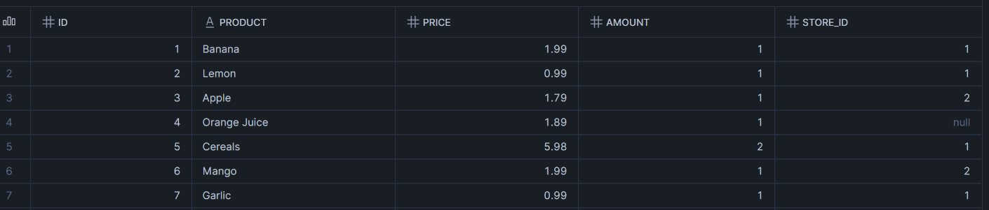
SELECT * FROM SALES_FINAL_TABLE;
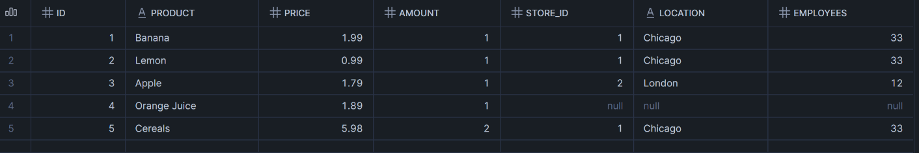
Answer this question:
Are the new records available in SALES_FINAL_TABLE before consuming the stream?
Ans:
No, new records are only in SALES_RAW_STAGING and SALES_STREAM and not yet in SALES_FINAL_TABLE.

Task 14: Consume Stream Data
Insert new records from SALES_STREAM into SALES_FINAL_TABLE.
While inserting, join the stream with STORE_TABLE using STORE_ID.

Query:
MERGE INTO SALES_FINAL_TABLE T
USING (
SELECT
S.ID,
S.PRODUCT,
S.PRICE,
S.AMOUNT,
S.STORE_ID,
ST.LOCATION,
ST.EMPLOYEES
FROM SALES_STREAM S
LEFT JOIN STORE_TABLE ST
ON S.STORE_ID = ST.STORE_ID
WHERE METADATA$ACTION = 'INSERT'
) SRC
ON T.ID = SRC.ID
WHEN MATCHED THEN
UPDATE SET
T.PRODUCT = SRC.PRODUCT,
T.PRICE = SRC.PRICE,
T.AMOUNT = SRC.AMOUNT,
T.STORE_ID = SRC.STORE_ID,
T.LOCATION = SRC.LOCATION,
T.EMPLOYEES = SRC.EMPLOYEES

WHEN NOT MATCHED THEN
INSERT (
ID,
PRODUCT,
PRICE,
AMOUNT,
STORE_ID,
LOCATION,
EMPLOYEES
)
VALUES (
SRC.ID,
SRC.PRODUCT,
SRC.PRICE,
SRC.AMOUNT,
SRC.STORE_ID,
SRC.LOCATION,
SRC.EMPLOYEES
);
Output:

Task 15: Verify Stream After Consumption
Query:
SELECT * FROM SALES_STREAM;
Output:

Answer this question:
Why did the stream become empty after inserting data into SALES_FINAL_TABLE?
Ans:
The stream became empty because it was consumed to insert records into the SALES_FINAL_TABLE.
Second Insert Change Capture

Task 16: Insert More Sales Records
Insert the following two records into SALES_RAW_STAGING:
id product price amount store_id
8 Paprika 4.99 1 2
9 Tomato 3.99 1 2
Query:
INSERT INTO SALES_RAW_STAGING VALUES
(8,'Paprika',4.99,1,2),
(9,'Tomato',3.99,1,2);

Output:

Task 17: Consume Second Stream Data
Consume the newly captured stream records and insert them into SALES_FINAL_TABLE.
Query:
MERGE INTO SALES_FINAL_TABLE T
USING (
SELECT
S.ID,
S.PRODUCT,
S.PRICE,
S.AMOUNT,
S.STORE_ID,
ST.LOCATION,
ST.EMPLOYEES
FROM SALES_STREAM S
LEFT JOIN STORE_TABLE ST
ON S.STORE_ID = ST.STORE_ID
WHERE METADATA$ACTION = 'INSERT'
) SRC

ON T.ID = SRC.ID

WHEN MATCHED THEN
UPDATE SET
T.PRODUCT = SRC.PRODUCT,
T.PRICE = SRC.PRICE,
T.AMOUNT = SRC.AMOUNT,
T.STORE_ID = SRC.STORE_ID,
T.LOCATION = SRC.LOCATION,
T.EMPLOYEES = SRC.EMPLOYEES

WHEN NOT MATCHED THEN
INSERT (
ID,
PRODUCT,
PRICE,
AMOUNT,
STORE_ID,
LOCATION,
EMPLOYEES
)
VALUES (
SRC.ID,
SRC.PRODUCT,
SRC.PRICE,
SRC.AMOUNT,
SRC.STORE_ID,
SRC.LOCATION,
SRC.EMPLOYEES
);
Output:

Task 18: Verify Final Insert Output
Display data from:
Query:
SELECT * FROM SALES_FINAL_TABLE;
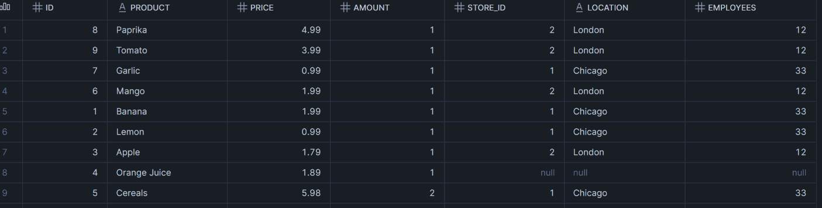

SELECT * FROM SALES_RAW_STAGING;
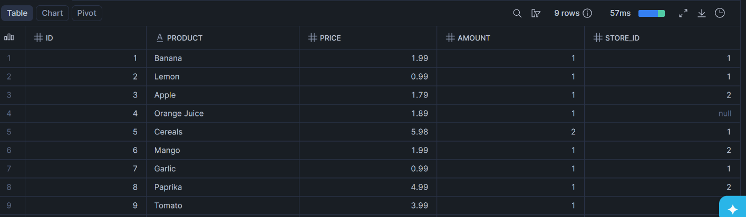
SELECT * FROM SALES_STREAM


Answer:
How many records are now available in SALES_FINAL_TABLE?
Ans:
After two streams consumption there are 9 records in SALES_FINAL_TABLE.
Update Change Capture

Task 19: Check Existing Data Before Update
Display records from:
Query:
SELECT * FROM SALES_RAW_STAGING;
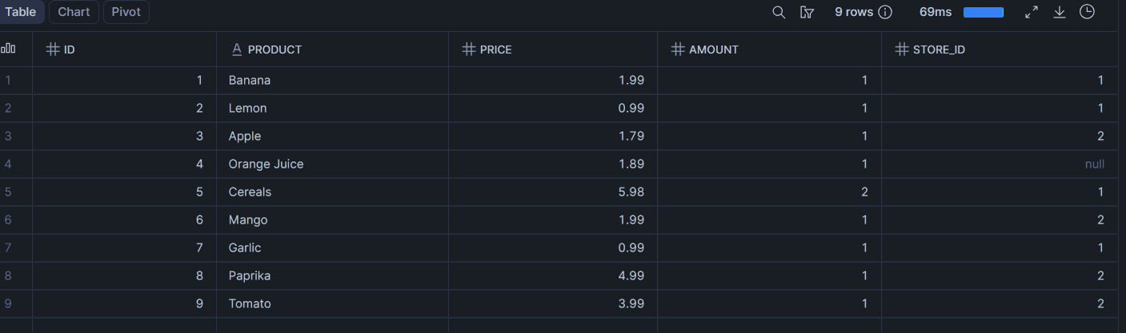
SELECT * FROM SALES_STREAM;


Task 20: Perform First Update
Update the product name:
Banana
to:
Potato
in SALES_RAW_STAGING.
Query:
UPDATE SALES_RAW_STAGING SET PRODUCT='Potato' WHERE PRODUCT='Banana';

Output:

Task 21: Check Stream After Update
Query:
SELECT * FROM SALES_STREAM;
Output:
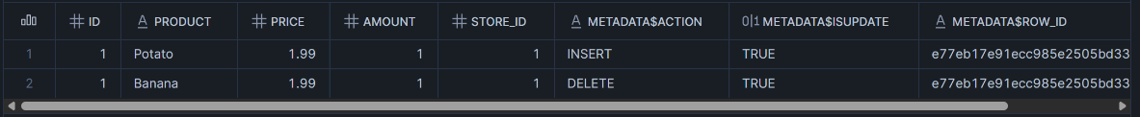
Answer:
How does Snowflake represent an UPDATE operation inside a stream?
Ans:
Snowflake represents UPDATE as DELETE+INSERT operations inside streams.

Task 22: Consume Update Using MERGE
Use a MERGE statement to update the corresponding record in SALES_FINAL_TABLE.
Condition:
Match records using ID
Update only records where METADATA$ACTION = 'INSERT'
and METADATA$ISUPDATE = TRUE
Update the following columns:
product
price
amount
store_id
Query:
MERGE INTO SALES_FINAL_TABLE T
USING (
SELECT
S.ID,
S.PRODUCT,
S.PRICE,
S.AMOUNT,
S.STORE_ID,
ST.LOCATION,
ST.EMPLOYEES
FROM SALES_STREAM S
LEFT JOIN STORE_TABLE ST
ON S.STORE_ID = ST.STORE_ID
WHERE METADATA$ACTION = 'INSERT'
AND METADATA$ISUPDATE = TRUE
) SRC

ON T.ID = SRC.ID

WHEN MATCHED THEN
UPDATE SET
T.PRODUCT = SRC.PRODUCT,
T.PRICE = SRC.PRICE,
T.AMOUNT = SRC.AMOUNT,
T.STORE_ID = SRC.STORE_ID,
T.LOCATION = SRC.LOCATION,
T.EMPLOYEES = SRC.EMPLOYEES

WHEN NOT MATCHED THEN
INSERT (
ID,
PRODUCT,
PRICE,
AMOUNT,
STORE_ID,
LOCATION,
EMPLOYEES
)
VALUES (
SRC.ID,
SRC.PRODUCT,
SRC.PRICE,
SRC.AMOUNT,
SRC.STORE_ID,
SRC.LOCATION,
SRC.EMPLOYEES
);

Output:
Task 23: Verify First Update
Display data from:
Query:
SELECT * FROM SALES_FINAL_TABLE;
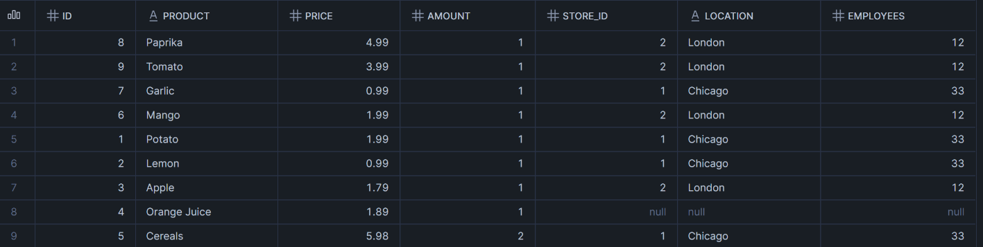
SELECT * FROM SALES_RAW_STAGING;
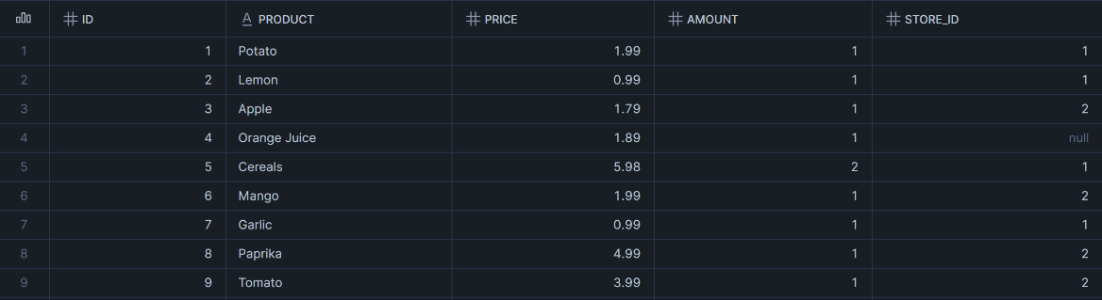
SELECT * FROM SALES_STREAM;
Answer:
Is Banana changed to Potato in SALES_FINAL_TABLE?
Ans:
Yes, after consuming the stream the Product=Banana changed to Potato in SALES_FINAL_TABLE.
Second Update Change Capture

Task 24: Perform Second Update
Update the product name:
Apple
to:
Green apple
in SALES_RAW_STAGING.
Query:
UPDATE SALES_RAW_STAGING SET PRODUCT='Green apple' WHERE PRODUCT='Apple';
Output:

Task 25: Consume Second Update Using MERGE
Use a MERGE statement to update the changed record in SALES_FINAL_TABLE.
Query:
MERGE INTO SALES_FINAL_TABLE T
USING (
SELECT
S.ID,
S.PRODUCT,
S.PRICE,
S.AMOUNT,
S.STORE_ID,
ST.LOCATION,
ST.EMPLOYEES
FROM SALES_STREAM S
LEFT JOIN STORE_TABLE ST
ON S.STORE_ID = ST.STORE_ID
WHERE METADATA$ACTION = 'INSERT'
AND METADATA$ISUPDATE = TRUE
) SRC

ON T.ID = SRC.ID

WHEN MATCHED THEN
UPDATE SET
T.PRODUCT = SRC.PRODUCT,
T.PRICE = SRC.PRICE,
T.AMOUNT = SRC.AMOUNT,
T.STORE_ID = SRC.STORE_ID,
T.LOCATION = SRC.LOCATION,
T.EMPLOYEES = SRC.EMPLOYEES

WHEN NOT MATCHED THEN
INSERT (
ID,
PRODUCT,
PRICE,
AMOUNT,
STORE_ID,
LOCATION,
EMPLOYEES
)
VALUES (
SRC.ID,
SRC.PRODUCT,
SRC.PRICE,
SRC.AMOUNT,
SRC.STORE_ID,
SRC.LOCATION,
SRC.EMPLOYEES
);

Output:

Task 26: Verify Final Output
Display data from:
Query:
SELECT * FROM SALES_FINAL_TABLE;
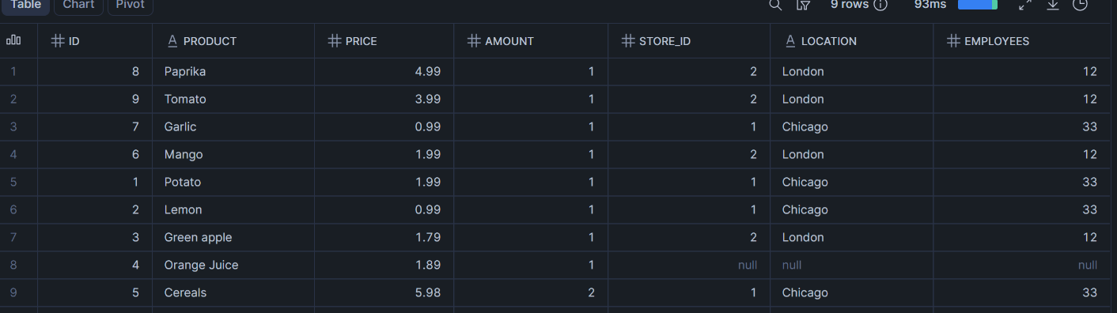
SELECT * FROM SALES_RAW_STAGING;
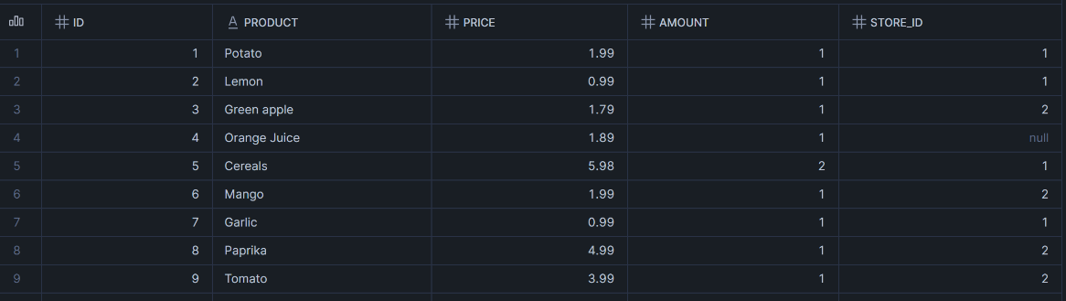

SELECT * FROM SALES_STREAM;

Answer:
Is Apple changed to Green apple in SALES_FINAL_TABLE?

Ans:
Yes, after consuming the stream the Product=Apple changed to
Green apple in SALES_FINAL_TABLE.

